Practical Report: Web Fundamentals – HTTP, HTTPS & Browser Developer Tools
Prepared by: Prabin Tamang
Topic: Understanding Web Communication and Browser Security
Date: 5 November 2026

1. Objective
The main objectives of this practical activity are:
- To understand the concepts of a web browser and web server.
- To learn how HTTP requests and responses work.
- To understand the difference between HTTP and HTTPS.
- To identify secure connection information in a browser.
- To inspect website network activity using Developer Tools.
- To understand HTTP status codes such as 200, 301, and 404.
- To practice safe and responsible web browsing.

2. Concept and Understanding

2.1 What is a Web Browser?
A web browser is a software application that allows users to access and view websites on the internet.
Examples:
- Google Chrome
- Mozilla Firefox
- Microsoft Edge
- Safari
A browser sends requests to web servers and displays the information received from them.

2.2 What is a Web Server?
A web server is a computer or software that stores, processes, and delivers website content to users through the internet.
When a user enters a website address, the browser sends a request to the web server. The server processes that request and sends back the requested information.

2.3 What is an HTTP Request?
An HTTP request is a message sent by a browser (client) to a web server to request information or perform an action.
Common HTTP request methods include:
- GET: Retrieves information from a server.
- POST: Sends information to a server.
- PUT: Updates or replaces a resource.
- DELETE: Requests deletion of a resource.

2.4 What is an HTTP Response?
An HTTP response is a message sent by a web server back to the browser after receiving a request.
It generally contains:
- Status code
- Response headers
- Response body (HTML, CSS, JavaScript, images, etc.)
For example, when a webpage loads successfully, the server may return the status code 200 OK.

3. Difference Between HTTP and HTTPS
HTTP | HTTPS
Hypertext Transfer Protocol | Hypertext Transfer Protocol Secure
Does not encrypt communication by itself | Encrypts communication using TLS
Data can be exposed during transmission | Helps protect data during transmission
Less secure for sensitive information | Provides a secure connection
Uses http:// | Uses https://
Explanation:
HTTPS is the secure version of HTTP. It uses TLS (Transport Layer Security) to encrypt communication between the browser and web server.
HTTPS also helps verify the website's server identity through its digital certificate.
However, HTTPS does not guarantee that a website is legitimate or free from malicious content.

4. Practical Activity: Inspect an HTTPS Website
Example website: Wikipedia
Follow these steps:
- Open Wikipedia in your browser.
- Check that the URL starts with https://.
- Click the site-information icon beside the address bar.
- Check the connection security information.
- Observe whether the browser reports a secure connection.
Observation: The browser indicates that the website uses HTTPS. The connection is encrypted using TLS, helping protect communication between the browser and server.
Screenshot evidence: Insert a screenshot of the browser's security information here.

5. Practical Activity: Inspect the Network Tab
Steps:
- Open Chrome or Firefox.
- Visit a public website.
- Press F12 or Ctrl + Shift + I.
- Select the Network tab.
- Reload the webpage.
- Observe the requests displayed.
- Check the Method, Status Code, and Type columns.

Network observation table
Resource | Method | Status | Type
Main webpage | GET | 200 | Document
CSS file | GET | 200 | Stylesheet
JavaScript file | GET | 200 | Script
Image | GET | 200 | Image
API request | GET/POST | Varies | Fetch/XHR
These are illustrative examples. Replace them with your actual observations.
Screenshot evidence: Insert your Network tab screenshot here. Do not expose sensitive headers or private information.

6. Explanation of HTTP Status Codes
Code | Meaning | Explanation
200 OK | Success | Request completed successfully.
301 Moved Permanently | Redirect | Resource has permanently moved to another URL.
404 Not Found | Error | Requested webpage or resource could not be found.

7. Safety and Privacy
During this activity, I followed these security practices:
- Did not collect cookies.
- Did not share passwords.
- Did not collect authentication tokens.
- Did not expose session identifiers.
- Used only publicly accessible websites.
- Avoided accessing private information without permission.

8. Result
After completing this activity, I understood how browsers communicate with web servers using HTTP and HTTPS. I learned how HTTPS protects communication through TLS and practiced inspecting website requests using browser Developer Tools.

9. Key Learnings
- A browser is used to access websites.
- A web server provides website resources.
- HTTP requests are sent from clients to servers.
- HTTP responses are returned by servers.
- HTTPS provides encrypted communication.
- Developer Tools help inspect website network activity.
- HTTP status codes explain request results.
- Private information must always be protected.

10. Conclusion
This practical activity helped me understand the fundamentals of web communication, HTTP, HTTPS, and browser security. I also gained practical knowledge of using the Network tab to observe website requests, methods, status codes, and resource types.
Prepared by: Prabin Tamang
Submission evidence to add:
HTTPS security information.
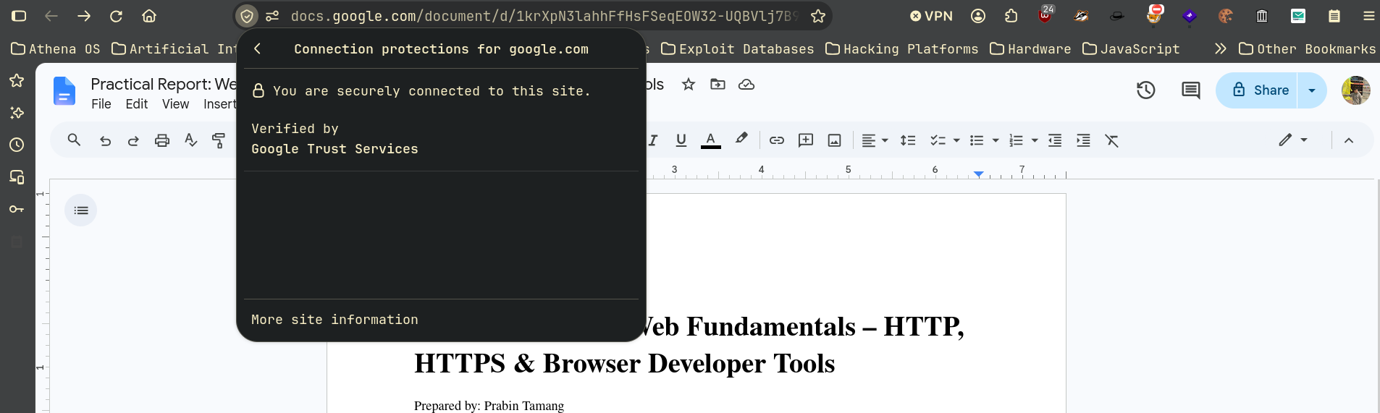

Browser Developer Tools – Network tab.


